**Creating Project**

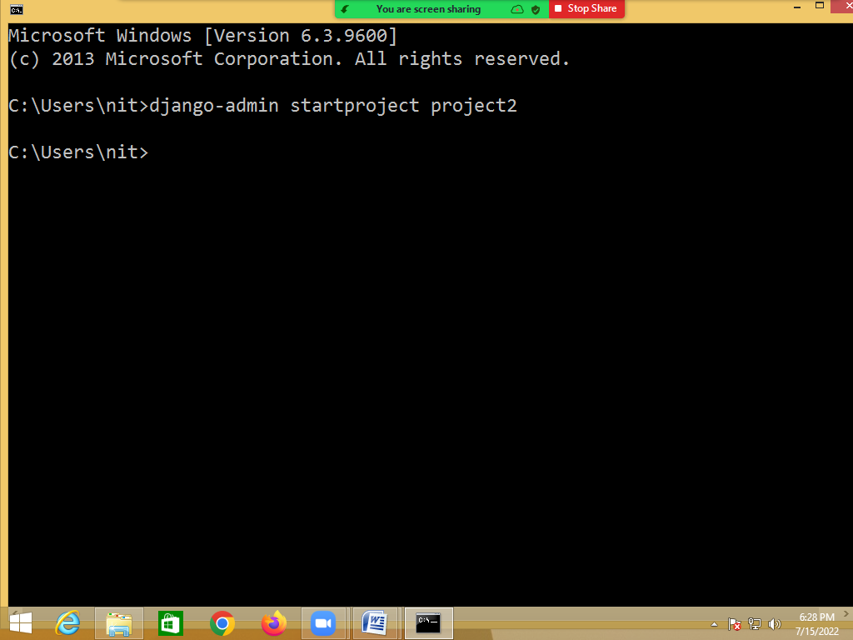

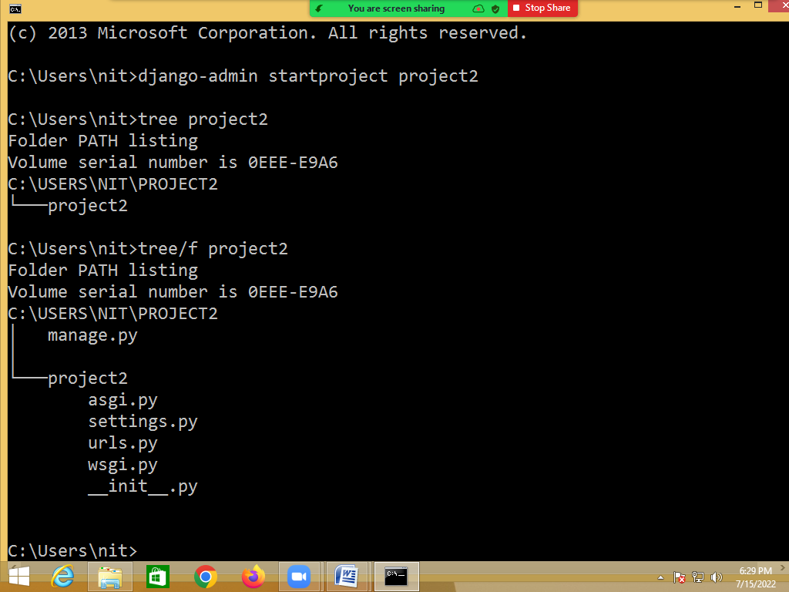

**Creating Application within project**

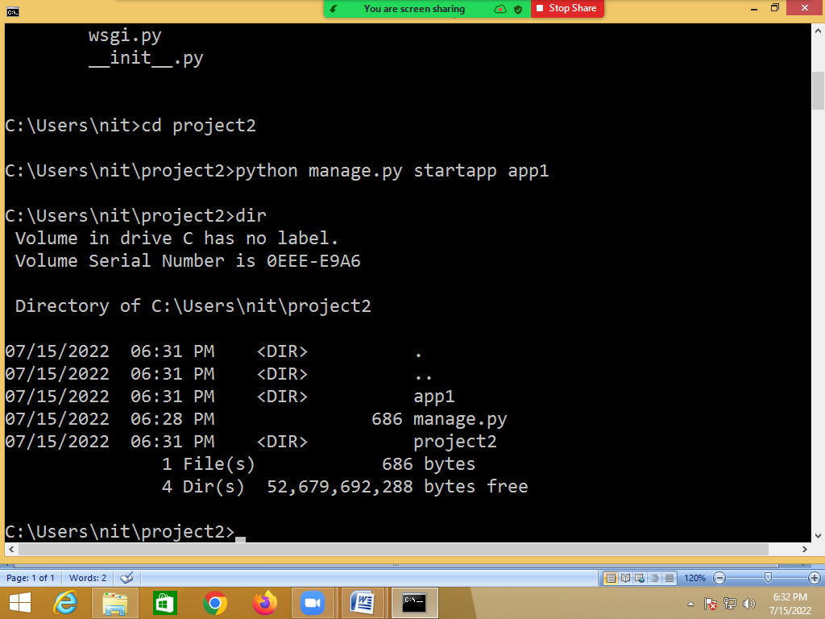

**Application consist of 6 modules and one folder**

**Application is a package. Each module is python program**

**1) __init__.py:**

It is a blank Python script. Because of this special name,Python treated this folder as a package.

**2) admin.py:**

We register our models in this file. Django will use these models with Django's admininterface.

**3) apps.py:**

In this file we have to specify application's specific configurations.

**4) models.py:**

In this file we have to store application's data models.

**5) tests.py:**

In this file we have to specify test functions to test our code.

**6) views.py:**

In this file we have to save functions that handles requests and return required responses.

**7) migrations folder:**

This directory stores database specific information related to models.

Note: The most important commonly used files in every project are views.py and models.py

**Registration of Application with project or how to install application within server or how configure application with server?**

1. Open project folder
2. Open package folder

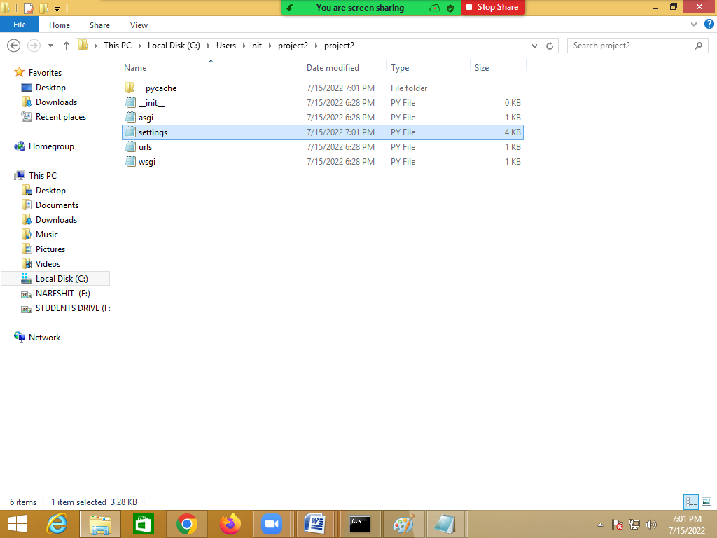

**INSTALLED_APPS = [**

**'django.contrib.admin',**

**'django.contrib.auth',**

**'django.contrib.contenttypes',**

**'django.contrib.sessions',**

**'django.contrib.messages',**

**'django.contrib.staticfiles',**

**'app1',**

**]**

**views.py**

from django.shortcuts import render

# Create your views here.

from django.http import HttpRespone

def display(request):

output="<h1> Welcome to Django </h1>"

return HttpResponse(output)

**urls.py**

from django.contrib import admin

from django.urls import path

from app1 import views

urlpatterns = [

path('admin/', admin.site.urls),

path('welcome/',views.display),

]

**Model**

Every project or web application required to store or save data permanently. We store or save data permanently within database.

Database is an application or software which holds data.

Database software’s or applications

1. Oracle
2. MySQL
3. SQLLite
4. SQLServer
5. PostgreSQL
6. MongoDB (NO SQL)

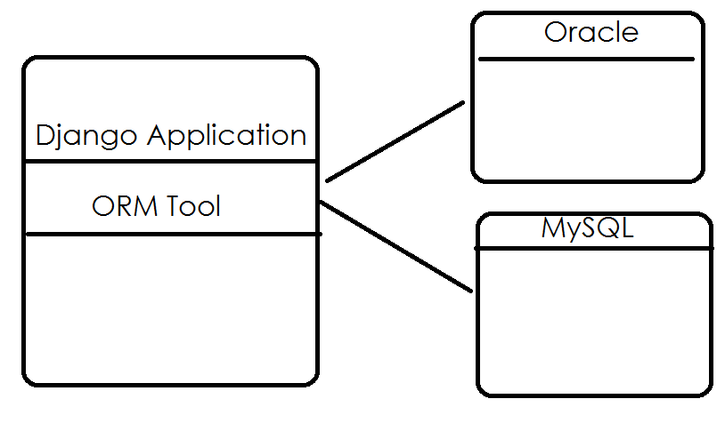

**What is ORM?**

ORM stands for Object Relational Mapping

ORM is specification which define set of rules and regulation which used to develop different ORM tools.